Tips, Tricks, and Activities: Teaching Math to 2nd Language Learners
WI TESOL Conference, 2019
Mark Sullivan

Warmup Activity: Can you solve it? Can you explain it?
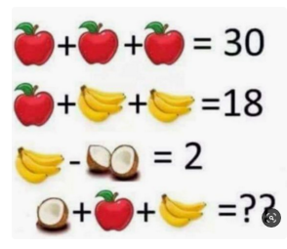

Background Information
- “International students, especially those bound for the United States, are heavily driven to study abroad by one factor: Improved career prospects.” wenr.wes.org
- “International students [focus] on STEM and business majors, majors which tend to lead to high earning careers.” -www.studyusa.com
- Teacher Education Programs “popping up:” Focus on STEM Field
- A need among international students for GRE Test Preparation
- English for Specific Purposes (ESP): A need for special programs for undergraduate and graduate degree-seeking students

Activity Ideas: Teaching Math + English
Activity 1 (Info Gap): Re-learn Basic Math Concepts | Activity 2: “Teachers” and “Students” Powerpoint Exercise | Activity 3: “Readers” and “Artists” Whiteboard Exercise
- Have students face each other in their chairs (across from each other)  - Pass out sheets (A sheet & B sheet)  - Do not show each other your sheets  - Model as a whole class  - Take turns asking & answering questions to determine the formulas  - Walk around & monitor; assist as needed | - Divide students into “Teachers” and “Students”  - Have them stand up “Teachers” face the board (PPT), and “Students” face away – not allowed to turn around  - “Teachers” read the problem aloud to “Students,” and they repeat (let them repeat multiple times)  - Everyone: Turn around and try solving the problem | - Divide students into “Readers” and “Artists”  - Give “Artists” a whiteboard marker and “Readers” the word problem  - Have them stand up “Artists” go to an area of the whiteboard with their marker  - “Readers” read the problem aloud to “Artists,” who then draw what they hear  - Once finished, solve the problem together using the drawing

Assessment Ideas
- Note-taking Skills
  - Use 3-column Note-taking System (www.youtube.com/watch?v=mr7dz-IEJTE)
  - Khan Academy (www.khanacademy.org) or Ted Talks (www.ted.com/talks)
- Math Presentation
  - Students choose a Math problem (a famous one or their own)
  - Students prepare a presentation, and explain “how to solve it” step-by-step
-International English Center, University of Colorado Boulder

Questions? My contact information is below:
Mark Sullivan
Lecturer, English Language Academy, University of Wisconsin-Milwaukee
Email: sullivam@uwm.edu; sullivanm444@gmail.com

