Teaching Diverse Adult ELL Populations Skills for Workforce Readiness
handouts & activities
cassie pilarski & Marie Simpson
2019

Activity 1: Competency Introduction & Exposure—Dialogue & Cloze

Dialogue 1:
Excuse me. My lamp doesn’t work! I think the lightbulb is burned out.
Don’t worry. I’ll tell maintenance. What is your room number?
I’m in room 215.
Ok. I’ll be back in a few minutes.
Thank you!

Cloze 1, Easy:
Excuse me. My ( lamp / light ) doesn’t work! I think the ( lights / lightbulb ) is ( clogged / burned out ).
Don’t worry. I’ll tell ( maintenance / a manager ). What is your room ( address / number )?
I’m in room ( 215 / 250 ).
Ok. I’ll be ( over / back ) in a ( few / five ) minutes.
( Thank you / You’re welcome )!

Cloze 1, Difficult:
__________ ______. My ________________ ( doesn’t / don’t ) work! I think the ________________ is
________________.
Don’t worry. I’ll tell ________________. What is your ________________ number?
______ ________ __________ ___________.
Ok. I’ll be _________ in a ( few / five ) ________________.
________________ ________________!

Activity 2: Writing Practice—Scaffolded Writing, Routines

1. Do you drink coffee everyday?
Yes, I drink coffee every day.
Are you drinking coffee right now?
No, I’m not.

2. Do you _________ to work every day?
Yes, I __________ to work every day.
Are you _____________ to work right now?
No, I’m not.
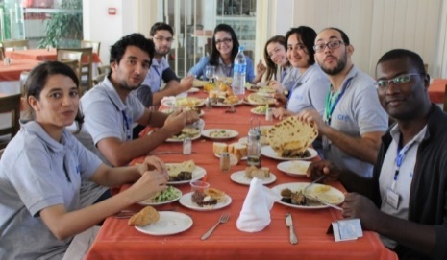
3. Do you _________ lunch every day?
Yes, I _________ __________ every day.
Are you ____________ ___________ right now?
No, I’m not.
4. _________ you _____________ dinner every day?
Yes, I _____________ ___________ every day.
_______ you ______________ ___________ right now?
No, I’m __________.
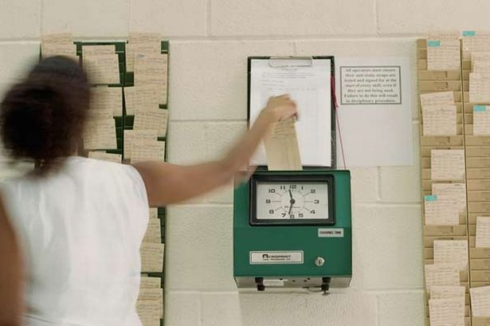
5. _______ you ____________ in __________ day?
Yes, I ____________ in ____________ ___________.
______ you ________________ in right now?
No, _______ _________.

6. __________________________________________?
Yes, ______________________________________.
___________________________________________?
No, _______________________________________.

Activity 3: Writing Practice—Scaffolded Writing, Job Experience
My Visit to the Job Center
Job Agent: Hello! Welcome to Wisconsin Job Center. How can I help you?
You: I’m looking for a new job.
Job Agent: Okay. Do you have a job now?
You: ____________________________________________________________________________________.
Job Agent: Okay. What are your job duties as _______________________________________________________?
You: ______________________________________________________________________________________
__________________________________________________________________________________________
__________________________________________________________________________________________
Job Agent: Great! What kind of job do you want?
You: I want ______________________________________________________________________________.
Job Agent: What do you like to do?
You: I like ______________________________________________________________________________.
Job Agent: What skills do you have?
You: I can _______________________________________________________________________________
I can also ________________________________________________________________________________
Job Agent: Do you have a degree or technical training?
You: ___________________________________________________________________________________.
Job Agent: That’s great!

Activity 4: Speaking Practice—Conversation Exchange

Write the conversation on the board:

(In general) Do you _____?  Yes, I do.  No, I don’t. | Did you ____ yesterday?  Yes, I did.  No, I didn’t.

eat shrimp | go grocery shopping
watch TV | read a book
sweep the floor | go to class
play guitar | play soccer

Other Expansion Ideas:

- Realia (Whole or small groups): Ask students to bring objects/pictures/writing to class OR ask workplace for examples of commonly used materials OR teacher brings realia.
  - Take a picture of a sign you don’t understand at work
  - Pictures of competency-related signs
  - Forms—report forms, supply order forms, etc.
  - Teach or review vocab/spelling
  - Activity prompts (write a dialogue about this object)
- Dialogue Scramble (Partner/Small Group): Use previously made dialogues to create sentence strips. Play dialogue once, then have students work together to put the sentence strips in order. Play dialogue again for students to check their work. Have volunteers read conversation aloud for pronunciation practice.
- Matching (Partner/Small Group): Use current focus area to create matching activity. Using tactile activities and getting students moving will help them engage with the material in a different way!
  - Examples: subject/verb agreement, in/on/at, vocabulary with pictures, pronunciation
- Weekly Homework: Give students a short, easy way to practice competencies outside of class. Example:
List three common guest/customer complaints at your job. Write complete sentences.
1. _____________________________________________________________________________________
2. _____________________________________________________________________________________
3. _____________________________________________________________________________________
Ask a friend or coworker what they did over the weekend. What did you do over the weekend?
Who did you talk with? ____________________________

Activity 5, Soft Skills Class Survey

Survey: What’s Confusing at Work?
Think about your job. What are the most important topics for you to practice?
Choose 3 topics:
- Conversations in the break room  - Conversations with my supervisor  - Giving and receiving feedback  - Polite requests  - Following my schedule | - Participating in meetings  - Apologizing  - Disagreements with coworkers  - Talking on the phone  - Reporting a problem

Activity 6, Nonverbal Behavior Matching

Matching
Match the picture with its meaning.
1. ______ a. You are doing something wrong.

2. ______ b. I don’t care.

3. ______ c. Good job. I am happy.

